**Q5.Given an IP address range of 192.168.1.0/24, divide the network into 4 subnets.**

**Task: Manually calculate the new subnet mask and the range of valid IP addresses for each subnet.**

**Assign IP addresses from these subnets to devices in Cisco Packet Tracer and verify connectivity using ping between them.**

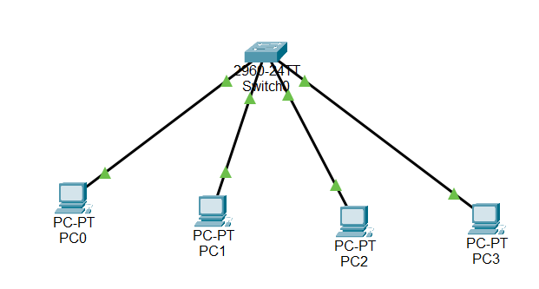

**Pinging PC0 to all other PC’s**

